Terminology:

i arbitrary element
I intensity
C concentration
STD standard reference material
SAMP sample (e.g. inclusion, mineral)
HOST host matrix (e.g. mineral)
BG background / gas blank

SIMPLE SIGNALS

The slope of the calibration plot of the i^{th} element is given by the expression:

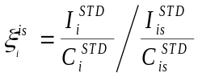 or 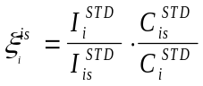

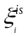 is thus the analytical sensitivity of the i^{th} element (in cps/ppm) relative to the internal standard is, as measured in a standard reference material STD. Using this term, we can conveniently convert measured intensity ratios 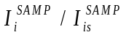into concentrations, provided the concentration of the internal standard is known:
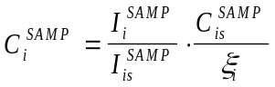

The limit of detection of the i^{th} element can be given by the expression:

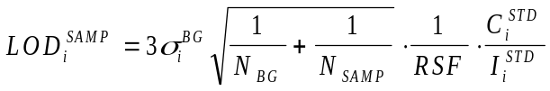

where 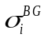is the uncertainty in the background (in cps); 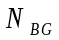and 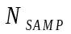 are the number of detector cycles in the background and sample integration windows, respectively; and 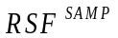is the relative sensitivity factor of the sample relative to the standard, which is defined by:

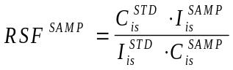 or 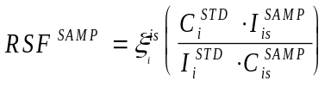

By substitution, the limit of detection can be re-written in terms of the calibration slope:

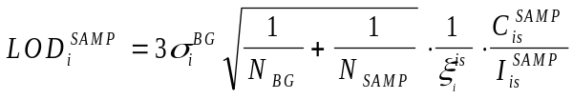

The above series of equations applies to the ablation of a sample, where

COMPLEX SIGNALS (hosts + samples)

The following series of equations pertain to LA-ICP-MS signals that can be described as a linear combinations of a gas blank (background), a matrix (e.g. a mineral host), and an unknown (e.g. a fluid or melt inclusion). These equations are based on those in Halter et al. (2002), but are rewritten in terms of 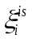where applicable.

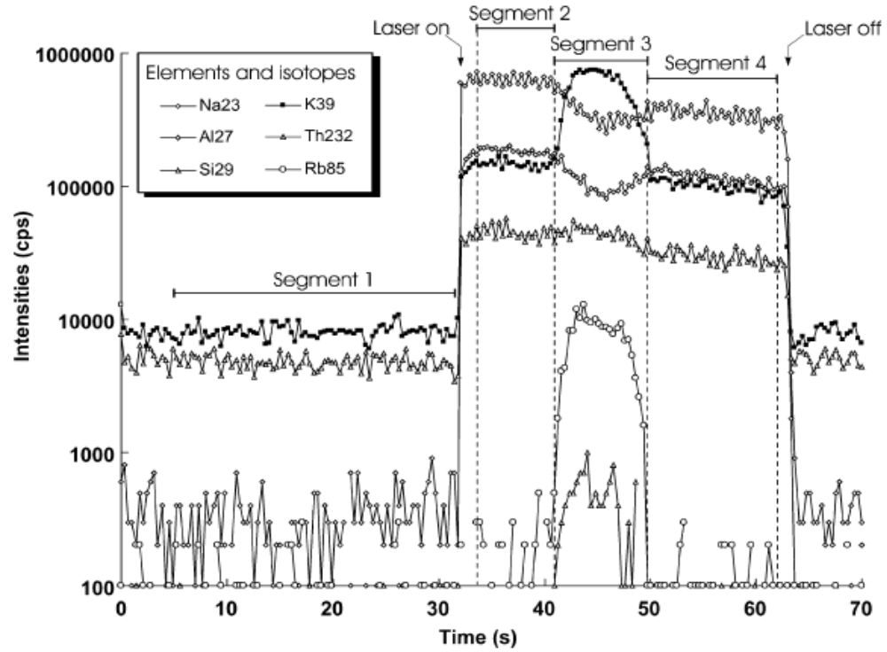
SIG1

SIG2
SIG3
SIG4
Fig.1. Example LA-ICP-MS plot of a plagioclase-hosted melt inclusion. SIG1: gas blank (background); SIG2: plagioclase host; SIG3: melt inclusion; SIG4: plagioclase host. From Halter et al (2002).

Figure 1 shows a typical transient LA-ICP-MS signal, where a host mineral correction is applicable. The signal can be broken down in to 3 basic SIGs: gas blank (SIG1), host mineral (SIG2), and the inclusion (SIG3). The intensity of a given SIG can be expressed as a linear combination of individual components:

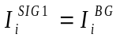
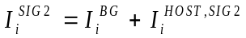
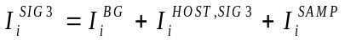

where 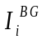is the intensity of element i in the background, 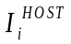is the intensity of the host in the designated time interval, and 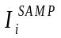is the intensity of the sample. It is also convenient to expression the background-corrected intensity in SIG3 as:

In principle the host region can be composed of several individual time slices (e.g. SIG2 and SIG4 in Fig.1). The sample region can also be defined by multiple components. SILLS allows the user to select up to 2 time windows for the host and up to 3 time windows for the sample.

In order to define the concentration of i in the sample (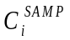), it is necessary to define the mixing ratio between sample and host in the mixed region (i.e. SIG3). The mass fraction x is given as the mass fraction of sample in the ablated mixture.

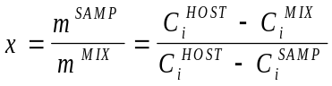

The expression can be rearranged to give:

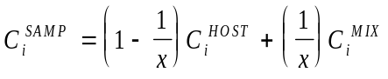

The concentration of i in the host and the mixed signal are respectively defined by the following:

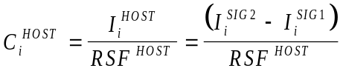
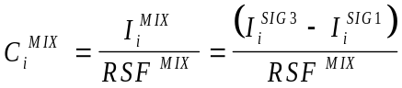

Substituting, the concentration of an element i in an inclusion can be expressed as:

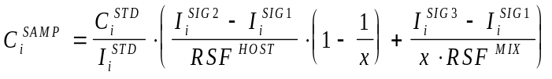

which can be rewritten as:

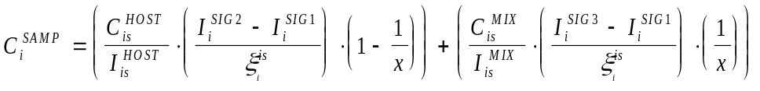

If there is no host correction, then 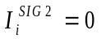,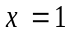, and 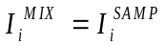, and the above expression simplifies to:

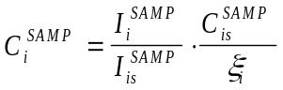, i.e. Equation *****

However, the general case requires that we define x.

Matrix-only tracer

If an element t occurs in the host mineral but not in the sample, we can define an intensity ratio RI for the host in SIG3 relative to the host in SIG2:

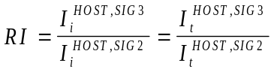

By definition, 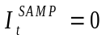 and thus 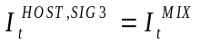. The term 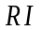is thus uniquely defined, and we can determine the sample intensity of all elements in the mixed signal:

From the above expression, the concentration of all elements can be defined. Although the mass fraction x is not required for concentration calculations, it can be expressed as:

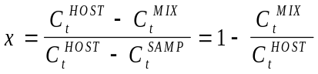

We can also state that:

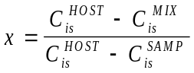

Although neither 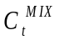 nor 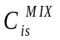are known, we can state that:

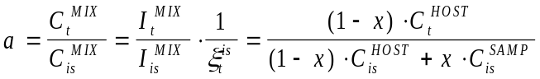

Solving for x:

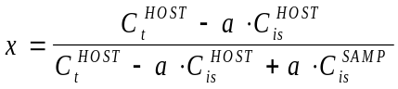

2nd INTERNAL STANDARD

An alternative constraint on the sample quantification procedure is a second element with a known concentration. With a matrix-only tracer, it was possible to calculate sample concentration from the corrected intensity of the mixed signal. With a 2nd internal standard, however, we must first determine the mass fraction x.

As above, we can express the concentration ratio a as:

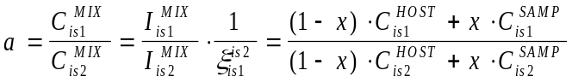

Solving for x:

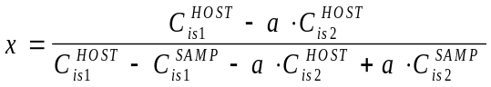

Now that x is defined, we can define the concentration of both internal standards in the mixture:

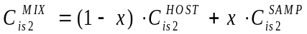

Using intensity ratios, 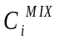can be defined for all elements in the mixed signal:

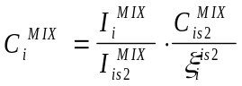

The sample concentration of all elements can now be defined:

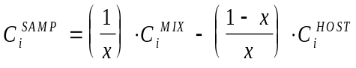

EQUATION-FITTING

Another strategy for determining sample concentrations is to fit the result to an equation of the form:

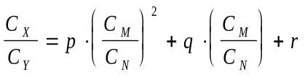

where 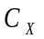etc. are the concentrations of elements X, Y, M, and N and p, q, and r are scalars. In SILLS, it is possible to set 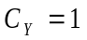 and 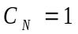to set an equation in terms of elements X and M only. Again, it is necessary to define the mass fraction x in order to calculate sample concentrations. The approach is to solve for x iteratively. First, we set x* = 0.5 and calculate the following, where variable with a * depend on the value of x*:

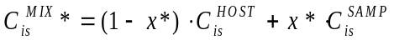
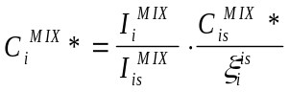
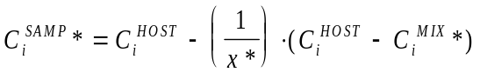
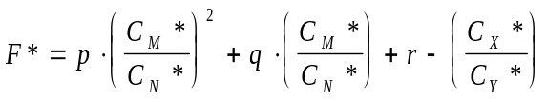

Iteration Procedure

The variable x* is varied iteratively until F* ~ 0 within the tolerance limit F* < 0.0001. First, boundary conditions are solved for x* = 0.0001 and x* = 1 to determine the limits of F* (note that F* is undefined at x = 0). A solution exists only if 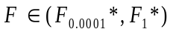. The iteration loop proceeds as follows:

if

if

if

if

if

if

calculate

Initial Conditions:

if

Halter, W. E., Pettke, T., Heinrich, C. A., and Rothen-Rutishauser, B., 2002, Major to trace element analysis of melt inclusions by laser-ablation ICP-MS: methods of quantification: Chemical Geology, v. 183, p. 63-86.

